**Boot camp for Digital Systems at St. Mary’s University**

Thanks to a grant from the IEEE Computer Society for Emerging Technology, the Lone Star Section Computer Society Chapter is offering a FREE Boot Camp for Digital Systems Education. The boot camp is for college, high school and continuing education students. It is designed to provide a hands-on experience at programming a low-cost field-programmable gate array (FPGA) board, the heart of many consumer electronic systems.

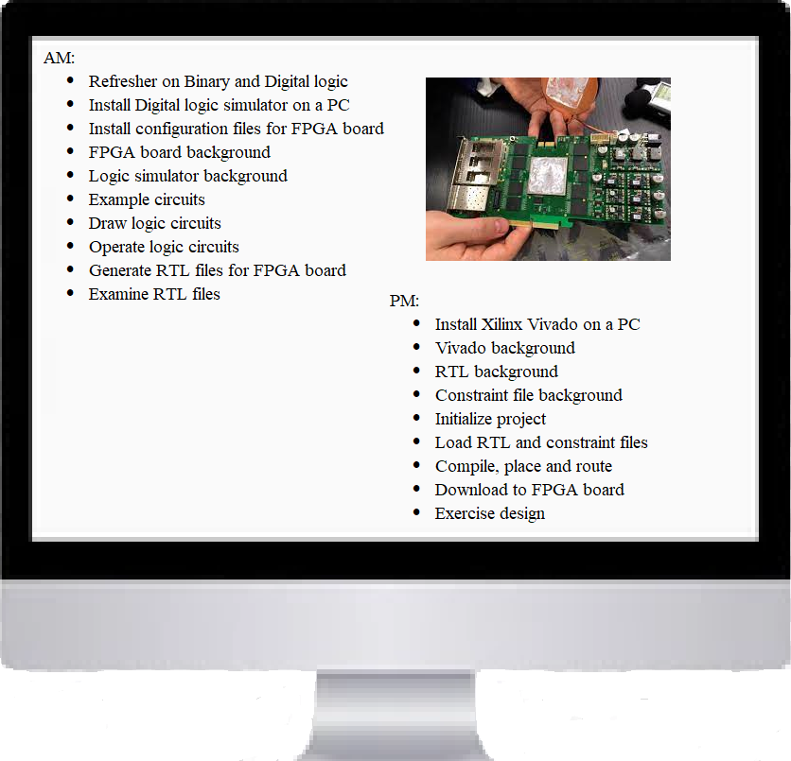

Lunch for participants will be provided. Boot Camp participants who attend the afternoon session keep their FPGA board. Please download, install and bring the Vivado tool ([www.xilinx.com](http://www.xilinx.com/)) onto your laptop with either Windows or Linux X86. If your PC does not have enough room, a 100GB flash drive will work.

At the end of the morning session, you should be able to create and exercise a digital schematic of your choosing. At the end of day, you should be able to exercise the digital design on the FPGA board. More information on the course and the slide decks are available at <https://github.com/jimbrake/FPGA_Boot_Camp>



*REGISTER AT:* [*https://bit.ly/3eIqru2*](https://bit.ly/3eIqru2) *--->*

*WHEN: Saturday* ***October 15****,* ***9am-5pm***

(lunch provided)

*LOCATION: St. Mary’s University*

*Richter* ***Math*** *Building, room* ***213***

*Use* ***parking lot D***